What is Aikido?

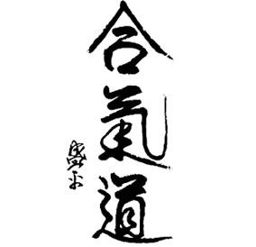

Aikido (合氣道) is a modern Japanese martial art that originates from a traditional system of combat, namely Daito-Ryu Aiki-Jujutsu. It was created by Morihei Ueshiba (1883-1969) and although he constantly kept evolving and refining his technique and philosophy, aikido took the form as we recognise it today in the last few years of the founder’s life.

Aikido was defined as “The Art of Peace” by the founder himself, and the three Japanese characters that comprise its name (Ai-Ki-Do/The Way of Aiki) can either be translated as, the way of harmony, or the way of harmonising with the will of the opponent, or, more philosophically speaking, the way of harmonising with the will of the Universe itself.

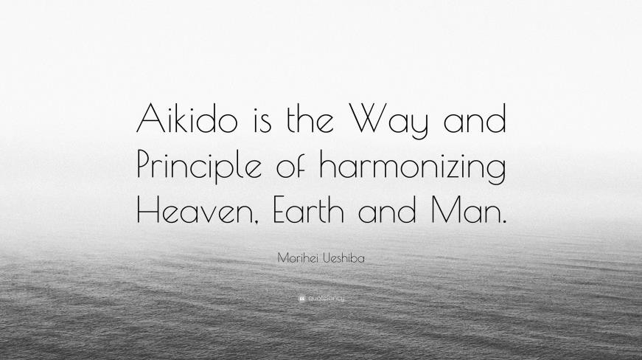

Aikido is formally classified as Budo (the Martial Way), not as a martial art with the modern dictionary definition meaning combat system and self-defence, but as self-development and knowledge of self. It is similar to other Japanese Koryu (traditional schools), such as Iaido (way of drawing a sword), Kyudo (way of the bow) and related arts. Aikido’s cultural heritage and its philosophical underpinnings, places it alongside these well-respected traditional martial arts that share and preserve the Japanese culture and history.

Ueshiba O Sensei (great teacher) was a very spiritual person and we are very fortunate to

have from him a wealth of articles and transcribed speeches about the principles of aikido and their core message. His personal religious beliefs and his experiences of conflict from war

and his own personal adventures, including many years of martial arts training, informed his ideas about aikido. He eventually came to emphasise the need for peace, love and harmony between all peoples of the Earth.

O Sensei viewed aikido as being a personal journey to understanding ourselves and our connection with the Divine/Universe. He considered spirituality to be integral to the development of aikido. However, nowadays we can safely decouple aikido from an exclusive spiritual medium, as long as we understand aikido to be a vehicle for strengthening our moral principles and finding an appropriate way, not only to provide a reference point to understanding ourselves, but also to inspire others to emulate an exemplary conduct. The journey to becoming a better person helps create the means for a better society and to bring back peace and harmony to a turbulent world.

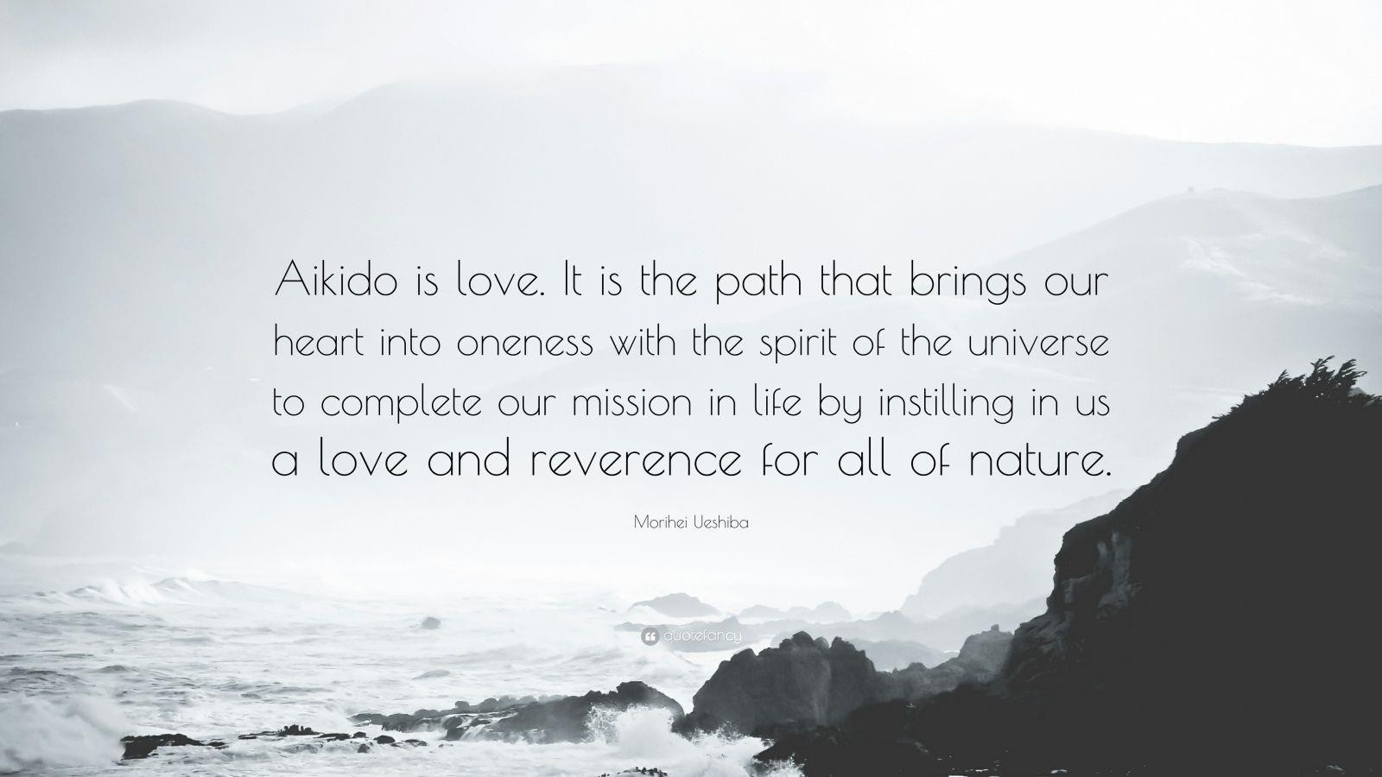

From the principles laid down by the founder, aikido can be better understood as the art of non-fighting. Although all techniques stem from physical conflict and are capable of serious physical injury, he developed his ideas and skills so that the possibility of consciously inflicting injury to your partner was removed.

To that effect, aikido neither prepares you for actual combat, nor encourages you to fight with another person. What it does however, and it does it really well, is to enable you to engage fully with the opponent, understand the motives and intentions behind a verbal or physical attack, blend with his/her intention and energy, and guide both the body and mind of the attacker to a mutually beneficial state of being. That means, a conclusion to the conflict

where no serious injury has been inflicted to the other party, no ego has been bruised and no desire for revenge has been generated.

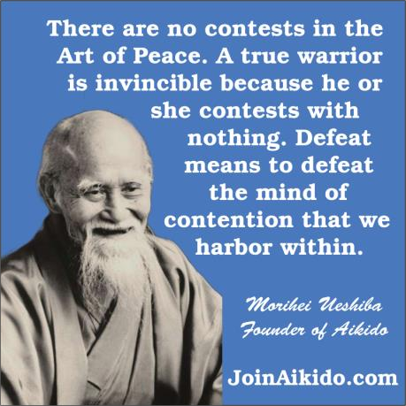

Aikido’s main raison d'être is actually off the mat. We are meant to embody and utilise its core principles in everyday situations, where conflict does not necessarily involve physical violence and weapons. To be able to practise these principles safely first, we need a controlled environment, the dojo (training hall).

Martial art techniques provide a suitable vehicle to experience alternative ways of coping other than flight or fight. In a graduating process, that needs to be carefully managed, students are increasingly exposed to the threat of a physical attack (a clear manifestation of conflict). They learn ways of preserving not only their own well-being, but also that of their

attacker. These same ideas can be taken into our daily lives to manage the day-to-day rigours of life.

The training done well not only positively transforms the lives of students, but impacts on anyone they interact with. In this way aikido offers a powerful “way to reconcile the world”, as O Sensei himself put it.

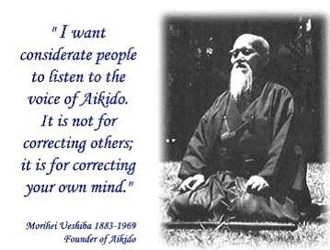

To conclude, using universal principles of body movement and a steadfast resolve to manage conflict well, aikido aptly solves the ethical dilemma of taking action that is both effective and benevolent when a challenging situation arises. If our mindset is not to win at the cost of anyone else, then not only have we achieved a victory over self, but created an environment where the other party can be a winner too. As Ueshiba O Sensei himself put it: “Masakatsu

Agatsu, Katsu Hayabi!”, meaning “True victory is victory over self, victory right here, right now!”

