

**Welcome to Burwell Dojo**

**A Founding Member Club of Aikido for Daily Life**

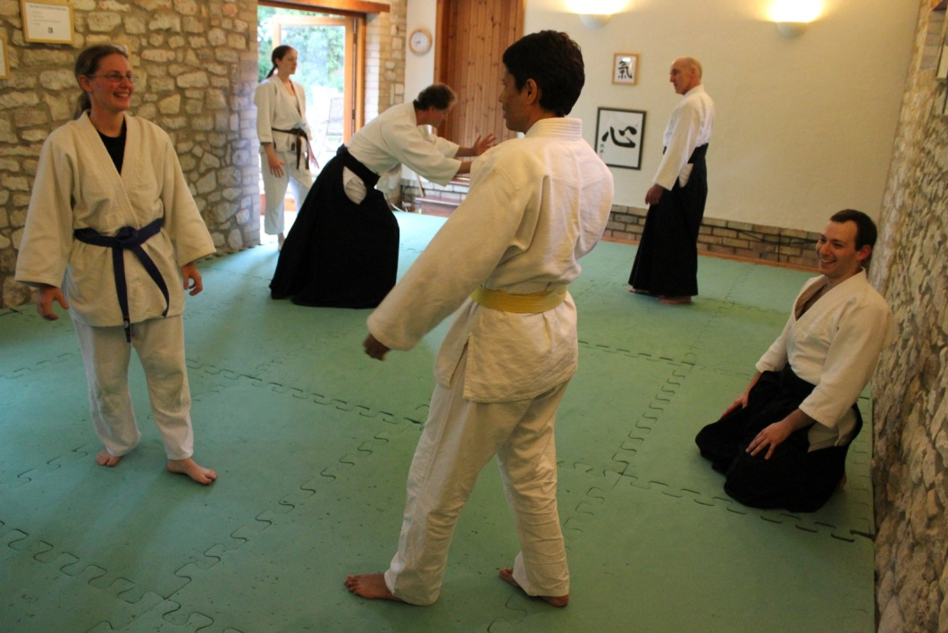

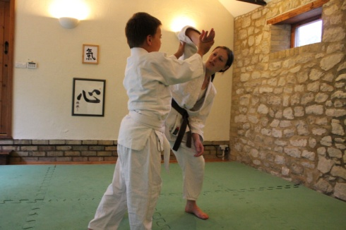 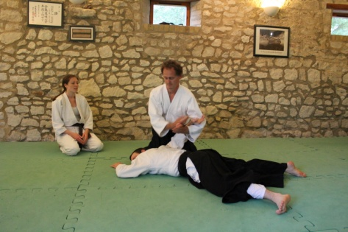

**Contact Details**

[**www.burwell-aikido.co.uk**](http://www.burwell-aikido.co.uk)

**Email:** [**q.cooke@ntlworld.com**](mailto:q.cooke@ntlworld.com)

**Tel: 01638 741678 (Home)**

**Tel: 01638 615343 (Work)**

**Welcome**

As a new student at Burwell Dojo, our aim is to make every lesson thought provoking, good for both your mind and body, but most of all enjoyable.

You may find some things new or unfamiliar. Here is some simple information about what you can expect at the dojo as you begin your Aikido training. We have included a description of our class structure as well as some suggestions for finding more information about Aikido in general.

Please train safely and, once again, welcome to Burwell Dojo.

**Classes**

*When?*

The usual schedule is:

Tuesdays 7.00pm - 9.00pm - all grades welcome

Thursdays 7.00pm - 9.00pm - all grades welcome

Saturday 10.00am – 12.00am

Classes cost £5 (£2 students/unwaged).

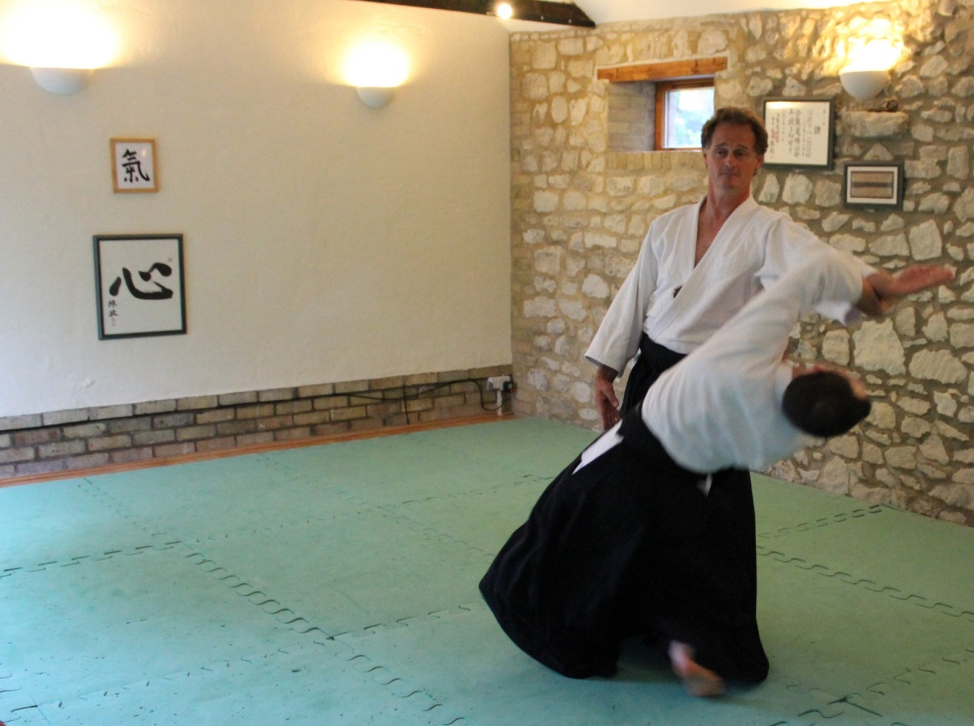

*Where?*

All classes held in the Barn Dojo at 16 Low Road, Burwell. Cambridge CB25 0EJ

Enter Low Road from Parsonage Lane. The dojo is in a barn building attached to half tiled and half thatched house opposite Casburn Lane.

**Principal Instructor -** Sensei Quentin Cooke 7th Dan

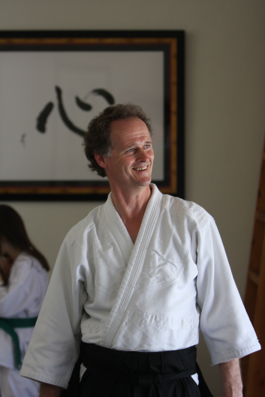

I began to practice aikido in 1984, within the Ki Society of Great Britain, which was linked to Tohei Sensei, but was headed up in this country by Sensei Kenneth Williams, who was one of the original practitioners of aikido in this country under Abbe Sensei. Sensei Williams eventually broke away and founded the Ki Federation of Great Britain, which I stayed with until 2000 having reached the rank of 4th dan.

At that point, being the creative art it is, I found that I needed to break away and explore new paths. I joined Sensei Denis Burke (a former assistant of Sensei Williams) and my brother Sensei Piers Cooke, who had founded the Isshinkai Association. It proved to be an organisation run on very similar lines to the KFGB and with the same philosophical problems, so as a result, my brother and I founded Aikido for Daily Life in 2004. Its aim is to try and do as the name suggests. ADL allows for a less conventional approach within the organisational structure. (I believe that if aikido is for daily life, that our experience on the mat should match our experience off it and that therefore the rather rigid structure of a traditional Japanese organisation is not something we should seek to replicate). The emphasis is very much on the philosophical nature of aikido, though it is important that the aikido performed on the mat is technically efficient

At the same time that we established ADL, we affiliated to the Aikido Yuishinkai International under Maruyama Sensei, who encourages people to celebrate what we share rather than seek to emphasise our differences, (There are many ways up the mountain). He promoted me to the rank of 5th dan.

In the summer of 2011, he rather extraordinarily promoted me to the rank of 7th dan.

I love my practice and study of aikido and believe it to be a powerful tool for improving the world we live in and my desire is to share it with as many people as I can.

**Club & Association Information**

Our website address is [www.burwell-aikido.co.uk](http://www.burwell-aikido.co.uk) and includes information about the dojo, galleries, calendars, teachers, newsletters and more. The best email address is [q.cooke@ntlworld.com](mailto:q.cooke@ntlworld.com). Feel free to ask any questions or raise any concerns, should you have them.

We are very proud to be members of Aikido for Daily Life, a very open and forward thinking Aikido association who strive to bring Aikido ideals out of the dojo and into every day life.

The association website address is www.aikidofordailylife.co.uk. More information can be found there as well as the links for the association discussion group. Aikido for Daily Life currently has dojo’s located in Aberdeen, Andover, Burwell, Coldharbour, Glasgow, Norwich, Reigate and Rusper, within the UK. We also have clubs in Athens and Calgary affiliated to us.

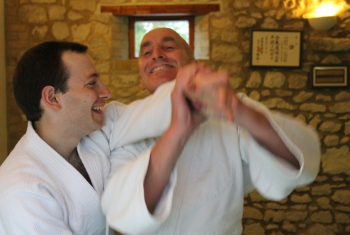

Our dojo is also a member of Aiki Extensions, which is an organisation dedicated to disseminating and applying aiki principles and methods outside the traditional martial arts training situation to improve the world we live in. AE supports some wonderful projects in troubled areas in the world, but at a more basic level seeks to reach out across the aikido community, encouraging aikidoka everywhere to work and train together, using aikido as a tool to building bridges. Aiki Extensions members have applied aiki principles in such areas as business, bodywork, psychotherapy, teaching, mediation, and sports. They have found that aiki principles enhance their professional effectiveness and personal well being. Visit www.aiki-extensions.org for further information.

Students from all styles of aikido are welcome to train with us as we are non-partisan in our approach. Friendship with other dojos is encouraged in keeping with the harmonious spirit of Aikido.

Finally we are an approved member of Peace Dojos International. A Peace Dojo is a martial arts school in which martial practice is explicitly oriented towards teaching skills of non-violence, conflict resolution, and peacemaking. Martial practice is uniquely valuable for practicing peace because attack/defence drills offer the opportunity to train oneself to receive an opponent in an empathic and harmonious way.

**More about Aikido for Daily Life**

Formed in 2004 by Sensei Quentin Cooke and his brother Sensei Piers Cooke with two main aims in mind. To have an organisation that sought to avoid politics of the worst kind and the sort of power struggles that go with this. On the mat, the principle feature of our style is to train in a way that is consistent with aiki principles which should be applied both on and off the mat. The fact is that most of us spend far more time off the mat than on it, and really our training on the mat should just be a preparation for what the rigours of daily life have to throw at us.

Although ADL has officers, all members have a say in how we are run and are responsible for appointing officers democratically. A copy of ADL’s constitution is available upon request, but can be downloaded from our website.

Through Aikido for Daily Life we are also members of the British Aikido Board – the national governing body for aikido in the United Kingdom, their website address is [www.bab.org.uk](http://www.bab.org.uk).

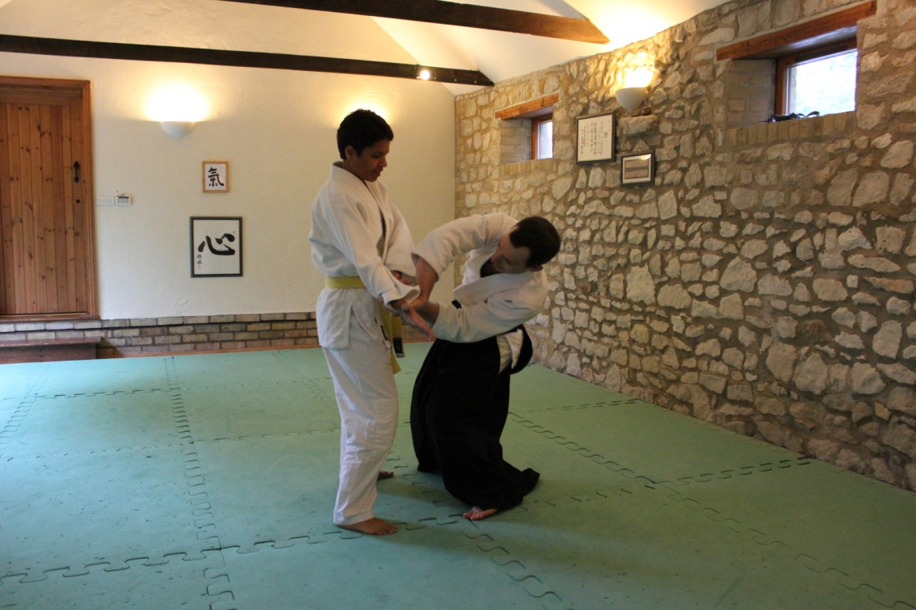

**Sensei Quentin Cooke’ Teaching Philosophy**

My ideas on teaching are detailed at some length below, but in essence it could be boiled down to ensuring that all who practice on my mat are safe and happy and have a positive environment in which to learn.

My own practice on the mat has often shown me that when describing a technique to students or working through faults in their own or my technique that I gain new insight into how the exercise in question works. It seems as if unconscious knowledge becomes conscious for the very first time. Doing something correctly and knowing why you are doing things correctly are two different things and the latter is far more helpful to the teacher. With this idea in mind, I hope to gain knowledge by placing my own teaching under the microscope and in so doing, improve on what I do.

At the heart of everything I do on the mat (and I hope off it), lies a very strong view of what aikido is all about. Practicing with many teachers and students over the years has taught me that my views about aikido are not the same as some and indeed, I am not even sure that they are the same as the majority. At the very least, I place a far greater emphasis on the underlying principles of aikido, because it seems to me that without a deep understanding of these, no technique can ever be truly mastered. I do not see aikido just as a martial art, but more as a philosophy for life. I am not even sure it is a martial art at all. It could be argued, and I frequently do, that it is just a means expressed through martial technique to learn how to deal positively with a negative situation. What could be more stressful than having someone attack you with a knife? If you can stay relaxed then and deal with the situation positively and to your maximum potential, you have a chance of dealing well with the stresses and strains of daily life.

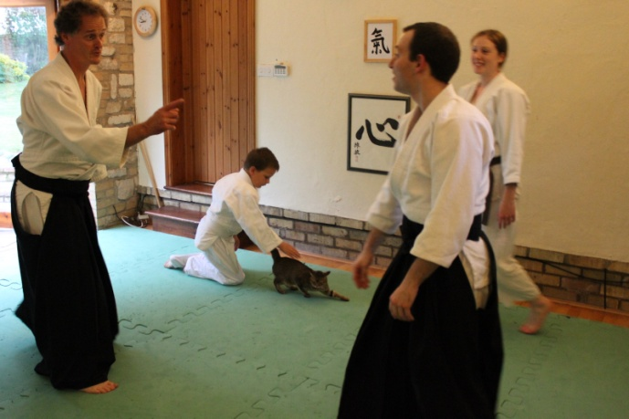

So what is my evidence base for this? The clue of course is in the name that the founder gave to this wonderful art. I am no expert on Japanese and I understand that there are a number of ways in which ‘Ai -Ki –Do’ could be translated, but broadly speaking, I have never heard anyone disagree with a translation of ‘The way of harmony with nature’. This phrase is brilliantly simple, yet so deep and encapsulates a whole life style. There is certainly no hint of violence or physical destruction in this. If this isn’t enough, then we can look at what the founder actually said. He said that aikido was essentially about love and described it as ‘a way to reconcile the world’. That was certainly his aim and put simply, he was taking technique that was originally designed to kill and maim and using this as a means to teach peace and love. The master of aikido doesn’t even have to consider their own personal safety.

Their aim is to protect the physical well being of their attacker and to find a positive resolution to an attack.

My teaching is governed by these ideas. The power of our martial technique and its potential to destroy is undoubted, but the aim must be that we can deflect and defend ourselves against any attack on our physical and indeed mental well being and in so doing protect and teach our attacker. If someone shows you kindness when you are mean, it is usually a very humbling experience, whereas if our mean spirit is met by an equally mean spirit, we feel justified in having acted as we did. Both parties usually leave the poorer for the experience.

I want my technique to work and to have no holes in it, but I want to be able to perform that technique in a way that does not damage my uke’s body. I want to leave him or her feeling exhilarated and wondering how they ended up where they did. I have never enjoyed learning through pain and suffering, but I pay a lot of attention when I am enjoying myself. Now there is definitely a school of thought in the martial world that believes that what doesn’t kill you is good for you and that if you survive the sometimes brutal training regime, then nothing can break you. In fact I think this is probably true. The trouble is that the percentage of people who do survive are so few, that to me this is a road leading to nowhere. In the event of survival, what sort of example would such a person be, when they come to teach others? Violence breeds violence and abuse breeds abuse. Equally love can be contagious too. If aikido is ever to truly change this world we live in, then we have to appeal to people from all walks of life. We have to make our practice enjoyable for those that step on the mat and find a way of reaching out to those who will never enter a dojo. Put simply, violence and the ability to destroy do not have mass appeal, love and peace do!

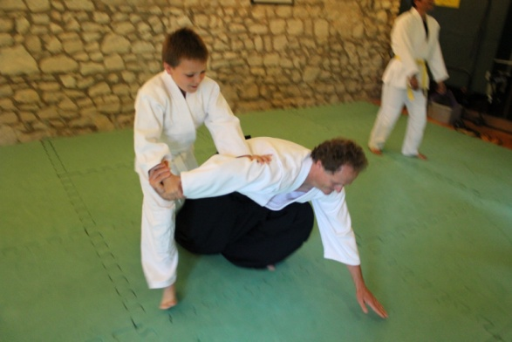

For me, it seems bit pointless to teach a skill that is quite likely to be completely unused once you step off the mat. I aim to give my students something that can make a difference in their daily lives and I tell them that what we do on the mat are ideas and principles that they can practice off the mat in virtually everything they do. Not all students continue to practice on the mat all of their lives and indeed, the vast majority drop out at some point. My hope is that no matter how long they train with me, something of what I shown them will stay with them for the rest of their days and improve their lives and those around them. If we all were to teach with aim in mind, and continue to light candles that can light candles, we can slowly but surely change our world for the better.

The above is what drives me and shapes everything I do by way of teaching aikido. I train students to be at ease with themselves and then at ease with their training partner. Coming from a ki aikido background, I have the four principles devised by Koichi Tohei Sensei, to teach students and act as a touch point for them to become instantly co-ordinated.

These are:

* Be centred.
* Focus outwards
* Relax completely.
* Work with gravity

All of these require demonstration, explanation and personal experience to get a handle on. The words themselves do not provide sufficient explanation.

The language we use on the mat is just as important as the way we physically demonstrate a technique and over the years, I have learned that I have to modify the words I use to explain things if I want to communicate accurately, what it is that I want my students to do. I try to avoid words like grab, pull, push, hit as all of these tend to have purely physical connotations and aikido if done just on a physical level simply doesn’t work. The basic martial technique might, but it isn’t aikido if you damage your partner or inflict pain upon them, which is what happens if you impose your will on theirs.

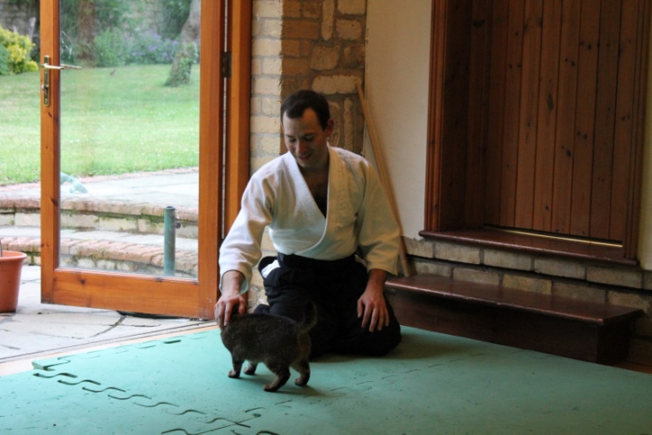

I believe that harmony within yourself comes from mind and body working positively together and it is no different when working with others. When working effectively on your own within the dojo or without, you have to be comfortable in your own skin, to use a phrase. It is no different when working with others, except the task becomes one of being harmonious with someone else. This is a bit like moving from open hand aikido to working with weapons. If your aikido is based on a concept of applying technique on someone else, then it is not aikido in my books. Aikido works, when two individuals are able to merge and effectively become one. If done in a spirit of love and compassion, then you can lead people wherever you like, because a human being is instinctively able to recognise that they are safe in this type of environment. Imposing your will on someone else will nearly always elicit a negative response, usually fear or aggression. Work positively with someone and there is a very good chance that you can find an outcome that is joyful for both.

Sometimes, words themselves seem inadequate to provide real meaning to a student. Some words have no meaning until you have experience of what they mean. For example, how do explain what ‘ki’ is to a new student. There are a number of phrases and definitions that I have at my fingertips, but frankly until you are able to work with someone on a physical level, and allow them to experience what ‘ki’ is, words can be pretty useless. Given this, a key tool for me when teaching is to explain things by using metaphors and similes that anyone is likely

to be able to relate to, through the normal course of living. I will adapt these to fit what I know about the individual. I might relate it to the job they do or other interests that they might have or their domestic circumstances. It is true that a picture paints a thousand words, and can get an idea across in a way that any description of the picture totally fails to do. Using pictures, metaphors and similes is a fast track way to impart knowledge.

It is my belief that everyone who steps on my mat can teach me something and has a unique gift to offer. I have had the privilege to study under and work with many great teachers over the years and all of them have shaped my aikido in one way or another, but the teachers who have had the greatest influence on me, have always been my own students. Their honesty and willingness to allow me to treat our dojo as a laboratory, somewhere where we all can experiment safely, has helped me grow in ways that a more conventional approach would never have allowed.

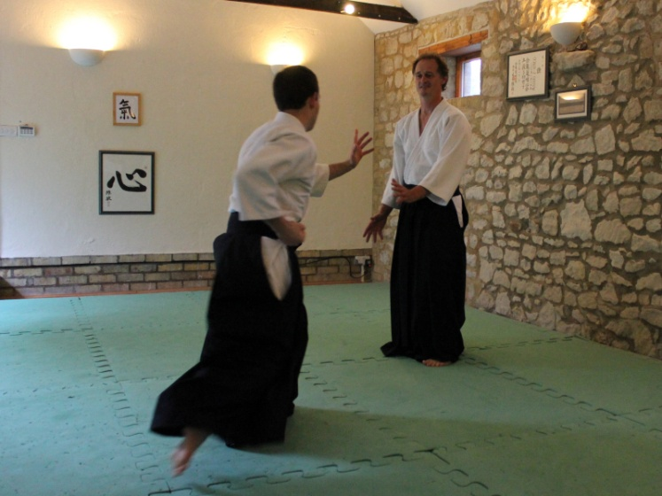

In practical terms this means that I actively train with my students. I do not just demonstrate the techniques that I want them to learn, but I actively participate in the training. I will work my way round the class and try to take ukemi for my students. I find that this is by far the best way of identifying where a technique is breaking down and it allows me to zero in and improve on what they are doing and also improve my own knowledge of a technique. Whilst some mistakes are common, every student has the ability to make unique mistakes of their own and identifying these, and putting these right, often provides you with information about a technique that you were never previously aware of.

My aim is to create an atmosphere that encourages investigation and questions, as this is the best way to allow all to flourish and grow. Being open to questions and allowing students to question my technique, allows me to try and justify and inform students, but on occasion to admit that maybe I do not have the answers or that I need to change. Allowing students to question you and accepting that you do not have all the answers brings rich rewards and a fast track to good learning for all.

As an add on to this, I believe it is vital that I keep in mind the fact that whilst I may know more about aikido than most of my students, they will have knowledge and insight that I do not. Furthermore their own unique experience of life will definitely give them gifts that I do not possess, so ensuring that this is respected and allowing them to bring their gifts to the table is vital.

I think it is important to adapt your teaching style and methods to reflect the culture that you work within. Aikido started in Japan, but their culture is very different to ours. I believe that a failure to recognise this will turn a lot of people off. Western society is not nearly so hierarchical and I think it is important to reflect this in the way my class works. I am not comfortable with the idea, that just because I might have more answers than most of my students when it comes to aikido technique, that I have all the answers when it comes to dealing with the daily business of living. It seems to me a ridiculous idea that when I was teaching at the age of 30, or 40 or 50 as I am now, that I will have the wisdom of some one aged 79, (the age of my oldest student). It is likely that such a person will have a much greater experience of what life has to offer than me. Equally I recognise that age isn’t necessarily a path to wisdom and knowledge and there is no reason why someone who is much younger than me, is not just as capable of teaching me something. I have been fortunate enough to live a fairly charmed life, and so I have never experienced some of the harsher realities of life that many others are forced to endure. All students deserve the utmost respect and have the capacity to amaze and inform you. I find that respect engenders respect and personally I am turned off by people who demand it. Respect has to be earned.

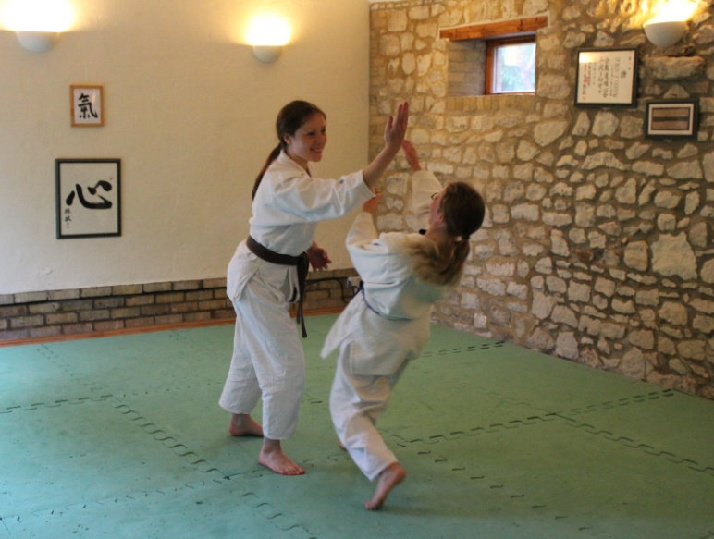

As I have suggested, every student comes to the mat with a unique experience of life and as such, everyone of them is an individual. As a teacher you need to be aware that different people learn in different ways. Some people learn best hearing the spoken word. Others do better from watching what you do and others need to feel a technique before they can begin to repeat it. More often than not, you need to use all three. Finding out what works best with each individual, and trying to ensure that the information you are attempting to impart is consistent across all modes is what I aim to do. Many is the time though that I am told that the words used suggested one thing, but that my body did something completely different.

I rarely approach the mat with a definite lesson plan, which seems to be the same for most teachers I talk to. At most, I might have one idea or concept that I want to explore. Often a simple phrase or idea will have come to mind, maybe whilst taking a shower or settling down before sleep. These eureka moments engender great excitement and I can not wait to take them to the laboratory and explore them. More and more I find that aikido is an instinctive and organic process and I trust these feelings more than ever. If it doesn’t feel right then I do not proceed, working out why it does or doesn’t, is how I grow.

Aikido is a hard task master as it sets high standards. I can not separate aikido and life and therefore I strive to act in a way off the mat that is consistent with what I teach on it. It is good to be mindful that students do not necessarily join your club to have you instruct them in how to lead their lives. Sadly the phrase that those that live in glass houses shouldn’t throw stones come to mind and I can think of all too many aikido teachers who whilst they demonstrate excellence on the mat, fail completely off it. Recognising that I am human and that I make mistakes like everyone else is vital and humbling. Just as on the mat I strive for improvement all the time, so I approach my daily life. Learning to forgive my failures has been hard at times, but is very necessary. When you sign on to study aikido, you need to recognise that you are embarking on a lifetime’s journey that has no end.

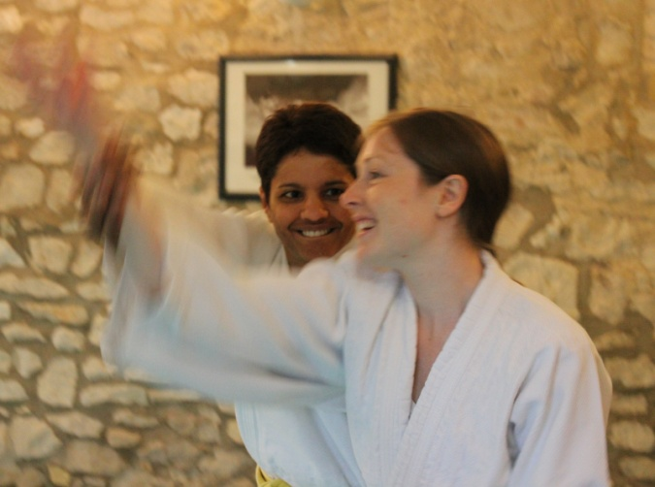

Finally, I think it is vital to respect the right of students on the mat and individuals off it, to hold a different view to mine. A constructive discussion on any point, may lead to a coming together of minds, but where it does not, it either means that I am not ready to accept the wisdom offered me or vice versa. On occasion we may just be viewing the same object from a different perspective and hence reaching a different conclusion. This standpoint determines what I see the role of the teacher to be. A good teacher is not the person who knows the most. He or she is the person who helps their students to maximise their potential and that might mean that they end up knowing more than you. The best definition I ever heard was that a teacher should shine a light to show a path that the student may not have otherwise have discovered for themselves. It is then up to them to decide whether this is a path worth travelling down. A teacher should recognise that every student carries their own light and may have their own paths to walk and discover for themselves.’

**What is Aikido?**

Aikido is a Japanese martial art developed by Morihei Ueshiba, (O Sensei), as a synthesis of his martial studies, philosophy, and religious beliefs. Aikido can be translated as meaning "the way of unifying (with) life energy" or as "the way of harmonious spirit." O Sensei's goal was to create an art that practitioners could use to defend themselves while also protecting their attacker from injury. Aikido is performed by blending with the motion of the attacker and redirecting the force of the attack rather than opposing it head-on. The aikidoka (Aikido practitioner) leads the attacker's momentum using entering and turning movements. The techniques are completed with various throws or joint locks. Aikido is a Japanese Budo and comes under the general umbrella of Jujutsu.

Aikido derives mainly from the martial art of Daito-Ryu Aiki-jujutsu, but began to diverge from it in the late 1920s, partly due to Ueshiba's involvement with the Omoto-Kyo religion. Many of O Sensei's senior students have different approaches to aikido, depending on when they studied with him. Today aikido is found all over the world in a number of styles, with broad ranges of interpretation and emphasis. However, they all share techniques learned from Ueshiba and most have concern for the well-being of the attacker.

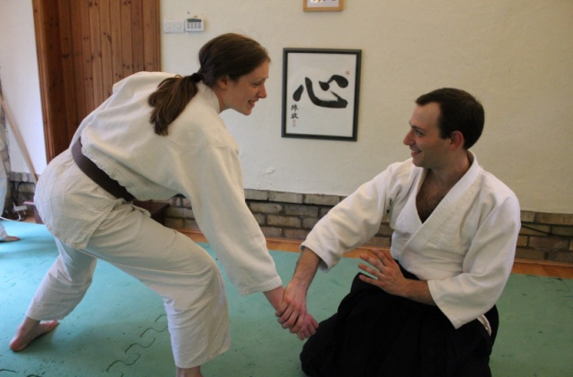

**Roles of uke and nage**

Aikido training is based primarily on two partners practicing pre-arranged forms (kata) rather than freestyle practice. The basic pattern is for the receiver of the technique (uke) to initiate an attack against the thrower (nage), who neutralises this attack with an aikido technique. Both halves of the technique, that of uke and that of nage, are considered essential to aikido training. Both are studying aikido principles of blending and adaptation. Nage learns to blend with and control attacking force, while uke learns to become calm and flexible in the disadvantageous, off-balance positions in which nage places them. This "receiving" of the technique is called ukemi.

Ukemi refers to the art of receiving a technique. Good ukemi involves blending or breakfalls that are used to avoid pain or injury, such as joint dislocations or atemi (strikes) - although aikido is not an aggressive art it is necessary to sometimes lead the mind of your partner or potential aggressor - a well placed strike at the right time may well help this.

**The Basic Class Structure**

At the beginning of class, students will line up kneeling facing the Ki and Shin sign, (acknowledgments to Quentin’s aikido heritage.

The instructor will come in front of the line to face the aforementioned signs.

The instructor will bow and the students will follow suit.

The instructor will turn to the class and everyone will bow together saying, “onegai shimasu” (“please train with me”). The instructor will then lead the class in warm-ups and exercises.

During class, the instructor will choose a student for a technique demonstration. After the demonstration, each student will bow to the instructor and then turn and bow to a fellow student next to them to practice what was just demonstrated. Each student will alternately take the role of nage (the person performing the technique) and then the role of uke (the person receiving the technique). Each student does the technique as nage four times and then as uke four times, alternating sides left and right each time they do a technique. If there is a third person, rotate them in round-robin style. During practice, the instructor may call for attention by clapping, to clarify a point; students will sit with their partner close by and then resume training with their partners after the clarification.

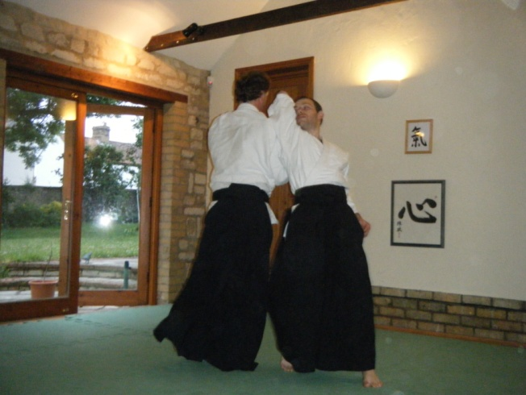

At the end of class, the students will line up as at the beginning of class and the instructor will bow to the Ki sign and the students will follow suit. The instructor will then turn to the class and everyone will bow together saying, “domo arigato gozaimashita” (“thank you very much”).

**Fitness**

Physical training goals pursued in conjunction with aikido include controlled relaxation, flexibility, and endurance, with less emphasis on strength training. In Aikido pushing or extending movements are much more common than pulling or contracting movements. In Aikido specific muscles or muscle groups are not isolated and worked to improve tone, mass, and power. Aikido related training emphasises the use of coordinated whole body movement and balance similar to Yoga or Pilates. Most classes start with warm-up exercises including stretching and breakfalls or rolling.

**Etiquette**

When entering or leaving the dojo, it is proper etiquette to bow in the direction of O-Sensei's picture. You should also bow when entering or leaving the mat.  
  
If you arrive late for a class then you should wait at the edge of the mat until the teacher gives you permission to join in.  
  
If you need to leave the lesson for any reason then it is usual to ask the teacher if that is ok, (it always is).  
  
Remove watches, rings and other jewellery before practice as they may catch your partner's hair, skin, or clothing and cause injury to yourself or your partner.  
  
Please keep your fingernails (and especially your toenails) clean and cut short.  
  
Keep your training uniform clean, and sweet smelling.

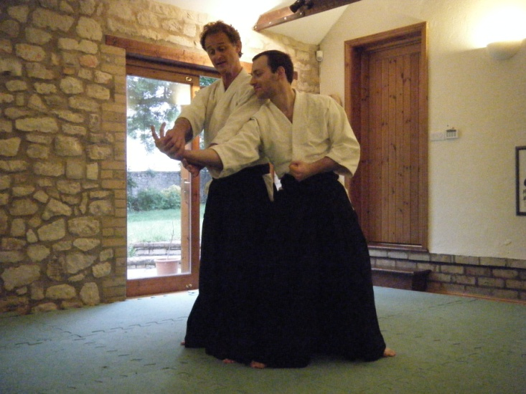

As in any class, it's best not to talk when the teacher is providing instruction. In some clubs, talking is frowned on at anytime, but in our club, we take a more relaxed view and encourage you to provide feedback to your training partner and indeed to the teacher.

Typically you should sit in seiza (kneeling down) when taking instruction. to acknowledge and thank the teacher it is normal to then bow to the instructor.

Whoever is teaching is referred to as 'Sensei' but only whilst they are teaching, if you're asked to show a technique then you become sensei for the duration of your technique. In our club, off the mat, everyone is on first name terms. Other clubs expect you to refer to the teacher as 'Sensei' at all times. (Worth knowing when you go on a course).

**Frequently Asked Questions**

**What kinds of people do Aikido?**

We have members from all walks of life - aikido is not limited to any one race, gender, sexuality, colour, religion or ethnic group.

**Do I need insurance?**

Yes! We will cover the cost of your insurance before you step onto the mat to practice. Your insurance will cover you world-wide and runs yearly from February to February.

**What do I wear?**

If you have done a martial art before then feel free to wear your existing suit, we only ask that you use a white belt if possible, if you've never done a martial art then wear something loose fitting.

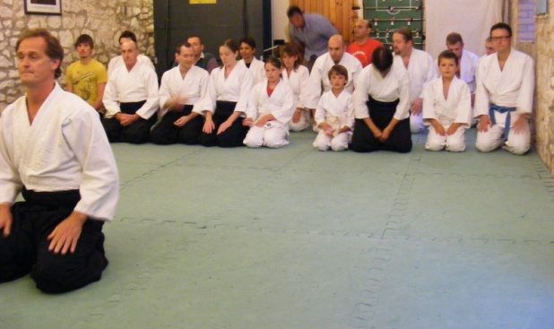

**How much does an Aikido suit (dogi) cost?**

Generally most people wear Karate or Judo type suits in order to practice aikido, they cost around £25 and are purchased at close to wholesale prices by Sensei Quentin Cooke on request.

**Can we train elsewhere?**

Your insurance allows you to practice at any club that is a member of the BAB. We hope that you will always feel that Burwell is your aikido home, but you are always welcome to train wherever and whenever you like.

**How do I join?**

We get you to fill in a membership form before practicing with us to ensure that you're insured however if you enjoy aikido then after 3 weeks we will ask you to become a member of our association – Aikido for Daily Life.

**How much is the membership?**

Membership fees run from annually from February and cost £28, (£16 students or anyone out of work) the fee is reduced proportionately every quarter.

**How often are gradings held?**

Whenever you are ready, we will arrange a date. Sometimes this will be within the club, but at dan grade it is usually elsewhere.

**Do I need to be fit?**

No, aikido is suited to all body types and all ages.

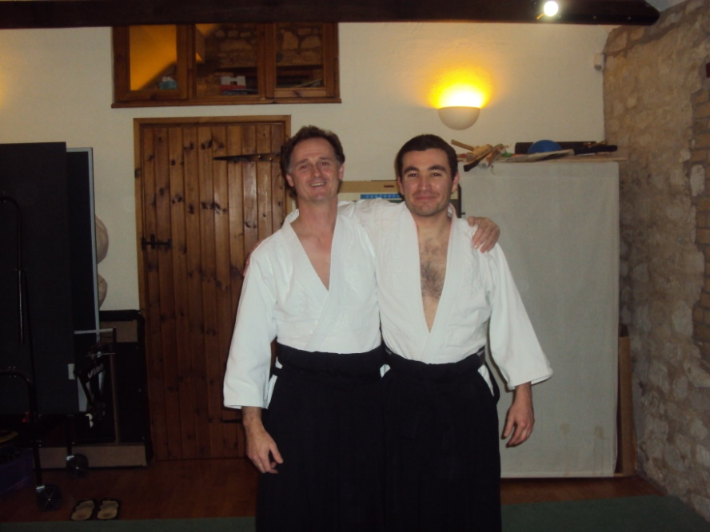

**I have a physical disability, can I still do aikido?**

Yes! The practice of aikido shouldn't be a problem to anyone. We can usually work with you to ensure we all have a safe and enjoyable practice with each other.

**I have a practised Aikido at another club; do I have to start again?**

No, definitely not! You have earned the current grade you are and we will happily recognise this, if it has been a long time since you practised and you wish to wear a white belt until you feel comfortable then this is okay by us.

**Child Protection Policy**

We want everyone and anyone to be able to practice at our dojo in safety and also to ensure that they leave with a smile on their face. This is no less true for our junior members than it is for anyone else. No club can operate these days without being aware of the issues involved in working with young people and the BAB are a great aid in keeping us abreast of what is expected.

Your children are welcome to practice with us, but at this point in time, we do not have a special class. However we do have a good record of successfully integrating children into our adult classes. If you want your children to practice then, please come along and see what we are about and talk with Sensei Cooke about your children and how best we can look after them

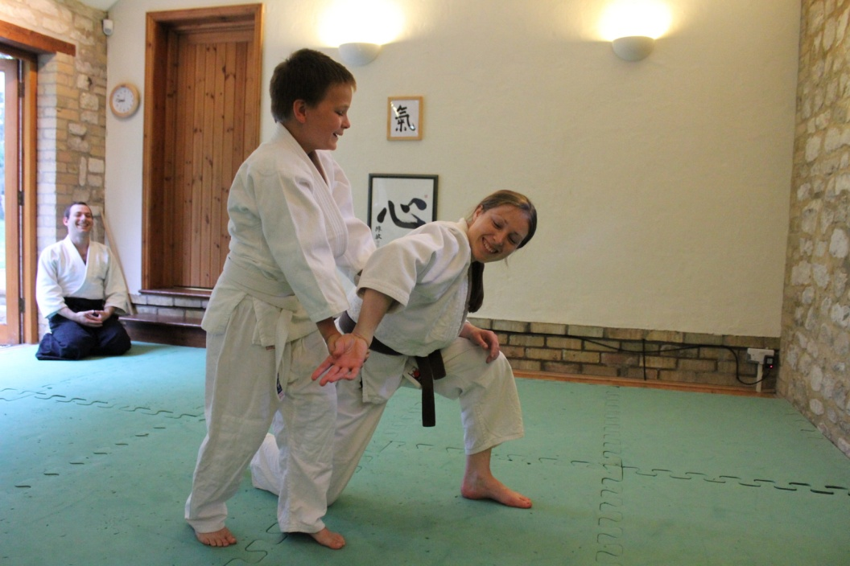

We do have an appointed Child Welfare Officer in the club and if you or your children have any concerns you should contact her. Her details are provided below:

**Laura Pugh**

**Home Tel No: 01223 971500**

**Mobile No: 07902 811538**

**Heath & Safety Policy**

1. No practice may take place unless a qualified coach is present.
2. It is the responsibility of the person in charge to ensure safe practice for all students.
3. A qualified first aider or responsible person should be present during practice.
4. The first aider or responsible person must know the location of a telephone for use in case of an emergency.
5. The full address and postcode of the dojo should be located next to the telephone.

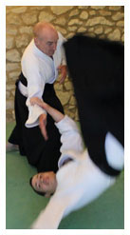

1. A suitable first aid kit must be available during practice.
2. In case of the practice mat being full all techniques must take in to account the nature of the dojo
3. Students must be made aware of the close proximity of the walls.
4. New students should be asked about any injuries or health problems before the start of practice.
5. All students must be made aware of the potential hazards of the access steps and stairs.
6. The three exits that might be used in case of fire must be kept clear at all times.

**Aikido for Daily Life Officers**

*Chairman (Burwell Club Teacher)*

Sensei Quentin Cooke (7th Dan) Tel: 01638 615343

*Head Coach (Coldharbour Club Teacher)*

Sensei Piers Cooke (7th Dan) Tel: 01306 711745

*Finance Officer & Database Protection Officer*

Sensei Piers Cooke Tel: 01306 711745

*Secretary*

Anita Lim email anitalim24@yahoo.co.uk

*Child Protection Officer*

Rob Brew Tel: 01360 550917

*Aberdeen Club Teacher*

Sensei Jo Duncan (2nd Dan) Tel 07869 038173

*Test Valley Club (Andover) Teacher*

Sensei Andrew Devereux-Smith (4rth Dan) Tel: 01264 336404

*Senshin Dojo Glasgow Club Teacher*

Rob Brew (4th Dan) Tel 07905 588026

*Norwich Club Club Teacher*

Steve Fyffe (5th Dan Tel 07815 946756

*Reigate Club Teacher*

Darren Bond Tel 07919 124651

*Rusper Aikido Club*

*Dan Easton 2nd Dan Tel 07812 114947*

*Membership Returns*

Daniel Easton Tel: 07812 114947

**Useful weblinks**

**Aikido for Daily Life** [**www.aikidofordailylife.or**](http://www.aikidofordailylife.or)**g**

**Aberdeen City Aikido Club http://jo-duncan-pgls.squarespace.com/**

**Senshin Glasgow http://www.senshindojo.org/**

**Burwell Club www.burwell-aikido.co.uk**

**Coldharbour Club** [**www.coldharbour-aikido.co.uk**](http://www.coldharbour-aikido.co.uk)

**Norwich Club** [**www.norwich-aikidofordailylife.com**](http://www.norwich-aikidofordailylife.com)

**Reigate Club** [**www.aikido-spirit.co.uk**](http://www.aikido-spirit.co.uk)

**Rusper Aikido Club** [**http://www.rusperaikido.co.uk**](http://www.rusperaikido.co.uk)

**Test Valley Aikido Club www.testvalleyaikido.co.uk**

**Calgary Club www.calgaryaikidofordailylife.com/**

**British Aikido Board** [**www.bab.org.uk**](http://www.bab.org.uk)

**Aiki Extensions** [**www.aikiextensions.org**](http://www.aikiextensions.org)

**Aikiweb** [**www.aikiweb.com**](http://www.aikiweb.com)

**Aikido Journal** [**www.aikidojournal.com/blog**](http://www.aikidojournal.com/blog)

